training 1 epoch...

122.61359524726868 seconds used......

1 training finished! average train loss: 0.6791547583906274

evaluating...

Confusion matrix, without normalization

[[ 255 24 15]

[1375 2383 63]

[ 134 16 692]]

Normalized confusion matrix

[[0.86734694 0.08163265 0.05102041]

[0.35985344 0.62365873 0.01648783]

[0.15914489 0.01900238 0.82185273]]

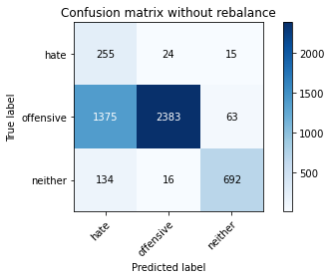

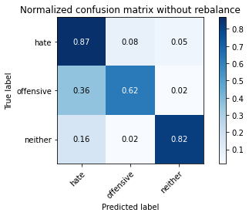

precision recall f1-score support

hate 0.14 0.87 0.25 294

offensive 0.98 0.62 0.76 3821

neither 0.90 0.82 0.86 842

accuracy 0.67 4957

macro avg 0.68 0.77 0.62 4957

weighted avg 0.92 0.67 0.75 4957

average eval_loss: 0.7178278729274554, accuracy: 0.6717772846479726

training 2 epoch...

121.99591779708862 seconds used......

2 training finished! average train loss: 0.4061018423618455

evaluating...

Confusion matrix, without normalization

[[ 217 48 29]

[ 643 3028 150]

[ 39 12 791]]

Normalized confusion matrix

[[0.73809524 0.16326531 0.09863946]

[0.16828055 0.79246271 0.03925674]

[0.04631829 0.01425178 0.93942993]]

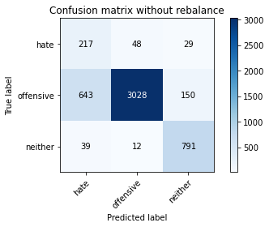

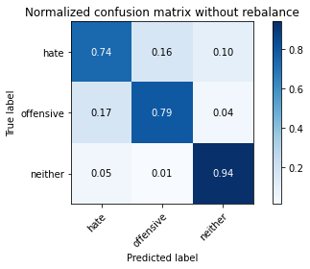

precision recall f1-score support

hate 0.24 0.74 0.36 294

offensive 0.98 0.79 0.88 3821

neither 0.82 0.94 0.87 842

accuracy 0.81 4957

macro avg 0.68 0.82 0.70 4957

weighted avg 0.91 0.81 0.85 4957

average eval_loss: 0.44608839285022545, accuracy: 0.8142021383901553

training 3 epoch...

121.9979600906372 seconds used......

3 training finished! average train loss: 0.2933856845882378

evaluating...

Confusion matrix, without normalization

[[ 221 47 26]

[ 707 2994 120]

[ 43 15 784]]

Normalized confusion matrix

[[0.75170068 0.15986395 0.08843537]

[0.1850301 0.78356451 0.03140539]

[0.05106888 0.01781473 0.93111639]]

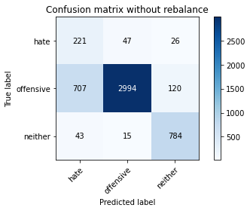

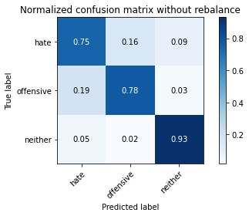

precision recall f1-score support

hate 0.23 0.75 0.35 294

offensive 0.98 0.78 0.87 3821

neither 0.84 0.93 0.88 842

accuracy 0.81 4957

macro avg 0.68 0.82 0.70 4957

weighted avg 0.91 0.81 0.84 4957

average eval_loss: 0.46988051926036256, accuracy: 0.8067379463385111

training 4 epoch...

122.15622663497925 seconds used......

4 training finished! average train loss: 0.20039364060779152

evaluating...

Confusion matrix, without normalization

[[ 235 47 12]

[ 862 2902 57]

[ 108 38 696]]

Normalized confusion matrix

[[0.79931973 0.15986395 0.04081633]

[0.22559539 0.75948705 0.01491756]

[0.12826603 0.04513064 0.82660333]]

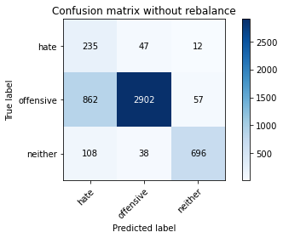

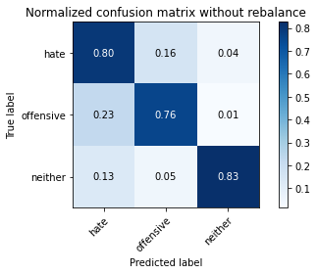

precision recall f1-score support

hate 0.20 0.80 0.31 294

offensive 0.97 0.76 0.85 3821

neither 0.91 0.83 0.87 842

accuracy 0.77 4957

macro avg 0.69 0.80 0.68 4957

weighted avg 0.92 0.77 0.82 4957

average eval_loss: 0.6139739103069434, accuracy: 0.7732499495662699

training 5 epoch...

122.23659992218018 seconds used......

5 training finished! average train loss: 0.12348372991025251

evaluating...

Confusion matrix, without normalization

[[ 248 34 12]

[1100 2650 71]

[ 112 19 711]]

Normalized confusion matrix

[[0.84353741 0.11564626 0.04081633]

[0.28788275 0.69353572 0.01858152]

[0.13301663 0.02256532 0.84441805]]

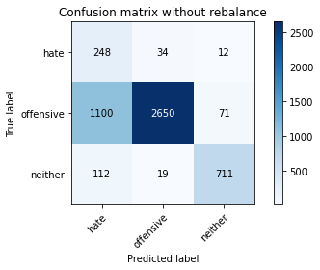

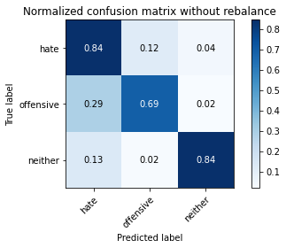

precision recall f1-score support

hate 0.17 0.84 0.28 294

offensive 0.98 0.69 0.81 3821

neither 0.90 0.84 0.87 842

accuracy 0.73 4957

macro avg 0.68 0.79 0.65 4957

weighted avg 0.92 0.73 0.79 4957

average eval_loss: 0.72328156739856, accuracy: 0.7280613274157757

training 6 epoch...

122.15145921707153 seconds used......

6 training finished! average train loss: 0.08648257363963414

evaluating...

Confusion matrix, without normalization

[[ 250 21 23]

[1292 2431 98]

[ 65 19 758]]

Normalized confusion matrix

[[0.85034014 0.07142857 0.07823129]

[0.33813138 0.63622088 0.02564774]

[0.07719715 0.02256532 0.90023753]]

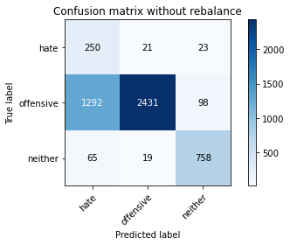

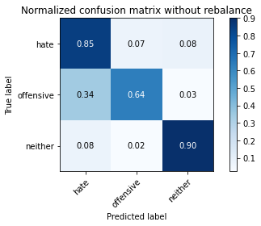

precision recall f1-score support

hate 0.16 0.85 0.26 294

offensive 0.98 0.64 0.77 3821

neither 0.86 0.90 0.88 842

accuracy 0.69 4957

macro avg 0.67 0.80 0.64 4957

weighted avg 0.91 0.69 0.76 4957

average eval_loss: 1.0268620262850987, accuracy: 0.6937663909622755

training 7 epoch...

122.16716718673706 seconds used......

7 training finished! average train loss: 0.07252007353389145

evaluating...

Confusion matrix, without normalization

[[ 192 76 26]

[ 571 3147 103]

[ 57 23 762]]

Normalized confusion matrix

[[0.65306122 0.2585034 0.08843537]

[0.14943732 0.82360639 0.02695629]

[0.06769596 0.02731591 0.90498812]]

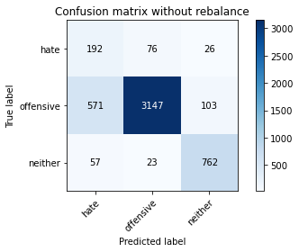

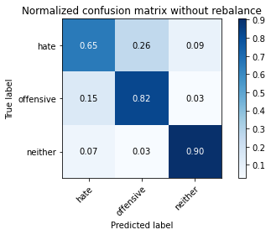

precision recall f1-score support

hate 0.23 0.65 0.34 294

offensive 0.97 0.82 0.89 3821

neither 0.86 0.90 0.88 842

accuracy 0.83 4957

macro avg 0.69 0.79 0.70 4957

weighted avg 0.91 0.83 0.86 4957

average eval_loss: 0.6463367074898239, accuracy: 0.8273149082106113

training 8 epoch...

122.04306101799011 seconds used......

8 training finished! average train loss: 0.039522784619628895

evaluating...

Confusion matrix, without normalization

[[ 214 54 26]

[ 655 3039 127]

[ 48 18 776]]

Normalized confusion matrix

[[0.72789116 0.18367347 0.08843537]

[0.17142109 0.79534153 0.03323737]

[0.05700713 0.02137767 0.9216152 ]]

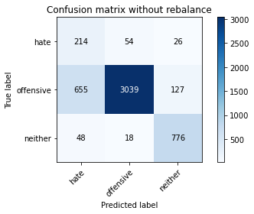

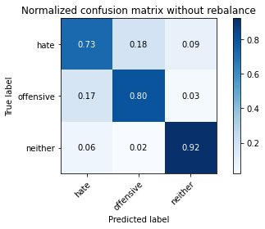

precision recall f1-score support

hate 0.23 0.73 0.35 294

offensive 0.98 0.80 0.88 3821

neither 0.84 0.92 0.88 842

accuracy 0.81 4957

macro avg 0.68 0.81 0.70 4957

weighted avg 0.91 0.81 0.85 4957

average eval_loss: 0.8051768267654541, accuracy: 0.8127899939479524

training 9 epoch...

122.21610879898071 seconds used......

9 training finished! average train loss: 0.02370024823712332

evaluating...

Confusion matrix, without normalization

[[ 234 47 13]

[1117 2627 77]

[ 104 25 713]]

Normalized confusion matrix

[[0.79591837 0.15986395 0.04421769]

[0.29233185 0.68751636 0.02015179]

[0.12351544 0.02969121 0.84679335]]

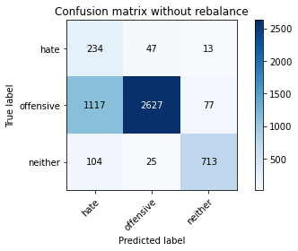

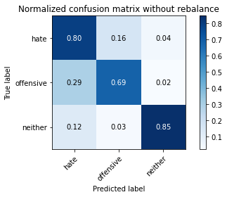

precision recall f1-score support

hate 0.16 0.80 0.27 294

offensive 0.97 0.69 0.81 3821

neither 0.89 0.85 0.87 842

accuracy 0.72 4957

macro avg 0.67 0.78 0.65 4957

weighted avg 0.91 0.72 0.78 4957

average eval_loss: 1.2902959477482785, accuracy: 0.721000605204761

training 10 epoch...

122.07399153709412 seconds used......

10 training finished! average train loss: 0.023184931460714882

evaluating...

Confusion matrix, without normalization

[[ 215 61 18]

[ 689 3046 86]

[ 77 29 736]]

Normalized confusion matrix

[[0.73129252 0.20748299 0.06122449]

[0.18031929 0.79717351 0.0225072 ]

[0.09144893 0.03444181 0.87410926]]

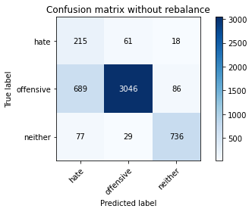

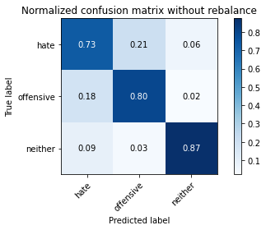

precision recall f1-score support

hate 0.22 0.73 0.34 294

offensive 0.97 0.80 0.88 3821

neither 0.88 0.87 0.88 842

accuracy 0.81 4957

macro avg 0.69 0.80 0.70 4957

weighted avg 0.91 0.81 0.84 4957

average eval_loss: 0.9073943599252793, accuracy: 0.8063344764978818